|  |  |  |  |
| --- | --- | --- | --- |
| **Name:** | George Miguel V. Batalan | **Date:** | 15/09/2023 |
| **Program:** | III-CPE | **Section:** | A361 |

**Intended Learning Outcomes:**

# Create output with JavaScript.

1. Utilize JavaScript variables and data types.

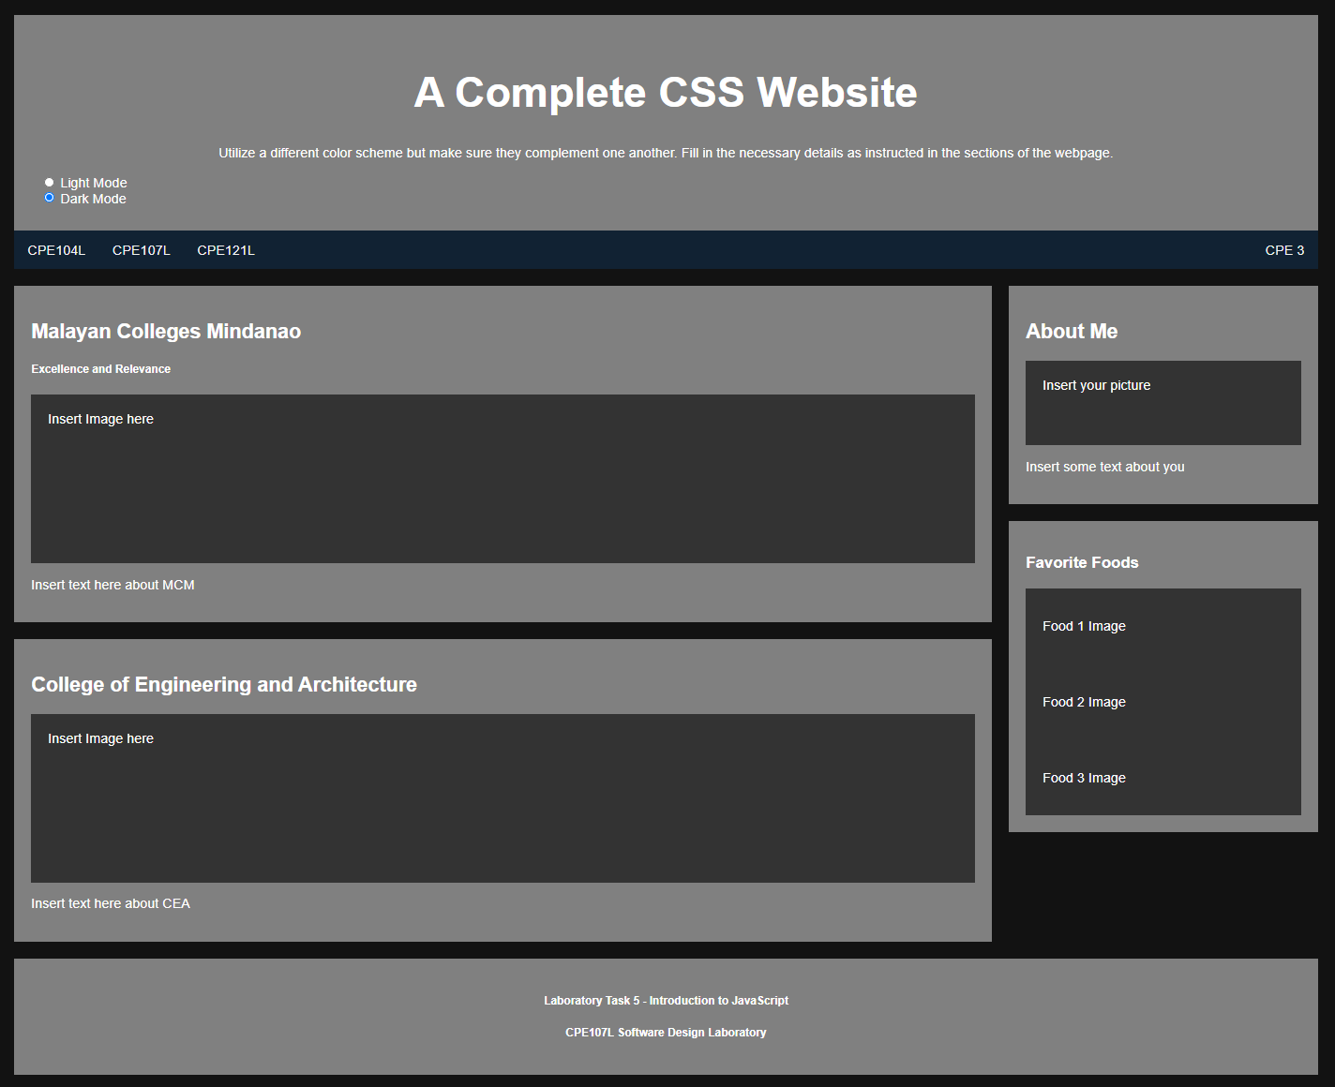

Using your output from Laboratory Task 4, include a button/check box/radio button/toggle switch that will change your website into **DARK MODE**. Here is an example output:

**CPE143L Web Design and Development**

================================================================================

**HTML Source Code:**

<!--Name: Goerge Miguel Batalan-->

<!--Course: Computer Engineering-->

<!DOCTYPE html>

<html>

<!-- linking CSS file to HTML file-->

<head>

<link rel = "stylesheet" href = "lab5.css">

<title> Laboratory Task 4 - A Complete CSS Website </title>

</head>

<body>

<header>

<script src = "java.js"></script>

<h1> A Complete CSS Website </h1>

<h6> By George Miguel Batalan </h6>

<button onclick = buttonMode()> Light Mode </button>

<button onclick = buttonMode()> Dark Mode </button>

</header>

<div>

<div class = "Nav">

<a href = "https://www.facebook.com/mapuamcm"> CPE104L</a>

<a href = "https://www.facebook.com/mapuamcm"> CPE107L </a>

<a href = "https://www.facebook.com/mapuamcm"> CPE121L </a>

<a class = "cpe" href = "https://www.facebook.com/mapuamcm"> CPE </a>

</div>

<div class = "box">

<div class = "school">

<h5> Mapua Malayan Colleges Mindanao </h5>

<p> Excellence and Relevance</p>

<img src = "MCM.png">

<div class = "mmcm">

<p> Malayan Colleges of Mindanao's motto is "Excellence and Relevance" that commits to produce globally

competitive professionals imbued with excellence, loyalty, teamwork, discipline, and sense of urgency. </p>

</div>

</div>

<div class = "myself">

<div class = "me">

<img src = "gunpoint.jpg" width = "100" height = "125">

<h5> About Me: </h5>

<details>

<Summary> Info </Summary>

<p> Name: George Miguel Batalan </p>

<p> Age: 21 </p>

<p> Occupation: Student </p>

<p> Address: NHA Bangkal, Apitong Street, Davao City </p>

</details>

</div>

</div>

<div class = "cea">

<h5> College of Engineering and Architecture </h5>

<img src = "CEA.jpg" width = "90%" height = "80%">

<div class = "whatcea">

<p> College of Engineering and Architecture (CEA) offers Architecture, Chemical Engineering, Civil Engineering,

Computer Engineering, Electrical Engineering, Electronics Engineering, Inudstrial Engineering and Mechanical Engineering.

Transforms its graduates to become globally competitive, innovative leaders, socially responsible and result-oriented engineers and architects. </p>

</div>

</div>

<div class = "food">

<h5> Favorite Foods </h5>

<p> Giniling </p>

<img src = "giniling.jpg" width = "125" height = "125">

<p> Sisig </p>

<img src = "sisig.png" width = "125" height = "125">

<p> Fried Rice </p>

<img src = "friedrice.jpg" width = "125" height = "125">

</div>

</div>

</div>

</body>

<footer>

<h3> Laboratory Task 4 - Advanced CSS Styling </h3>

<h3> CPE143L - Web Design and Development (Laboratory) </h3>

</footer>

</html>

**CSS Source Code:**

header {

text-align: center;

border-style: groove;

background: darkkhaki;

}

body {

background-color: white;

background-repeat: no-repeat;

background-attachment: fixed;

background-size: 100%;

text-align: center;

}

div.box{

width: 100%;

height: 100%;

display: flex;

flex-direction: row;

flex-wrap: wrap;

}

div.Nav {

background: khaki;

border-style: groove;

height: 30px;

font-size: 15px;

text-align: left;

font-family: "Times New Roman";

}

a.cpe {

float: right;

}

div.school{

width: 850px;

height: 450px;

background-color: darkkhaki;

padding: 1%;

margin: 1%;

border-style: groove;

}

div.me{

width: 350px;

height: 600px;

background-color: darkkhaki;

padding: 1%;

margin: 1%;

border-style: groove;

float: right;

}

div.cea{

width: 850px;

height: 850px;

background-color: darkkhaki;

padding: 1%;

margin: 1%;

border-style: groove;

}

div.food {

width: 350px;

height: 600px;

background-color: darkkhaki;

padding: 1%;

margin: 1%;

border-style: groove;

float: right;

}

.DarkMode {

background-color: saddlebrown;

color: white

}

.LightMode {

background-color: yellow;

color: black;

}

li{

font-size: 20%;

text-align:justify;

}

p {

text-align: justify;

}

h5 {

font-size: 125%;

}

footer {

border-style: groove;

background: khaki;

font-family: Arial;

font-size: 12px;

text-align: center;

padding: 1%;

font-weight: 100;

}

**JavaScript Source Code:**

function buttonMode(){

var element = document.body;

element.classList.toggle("DarkMode")

}

**Output:**

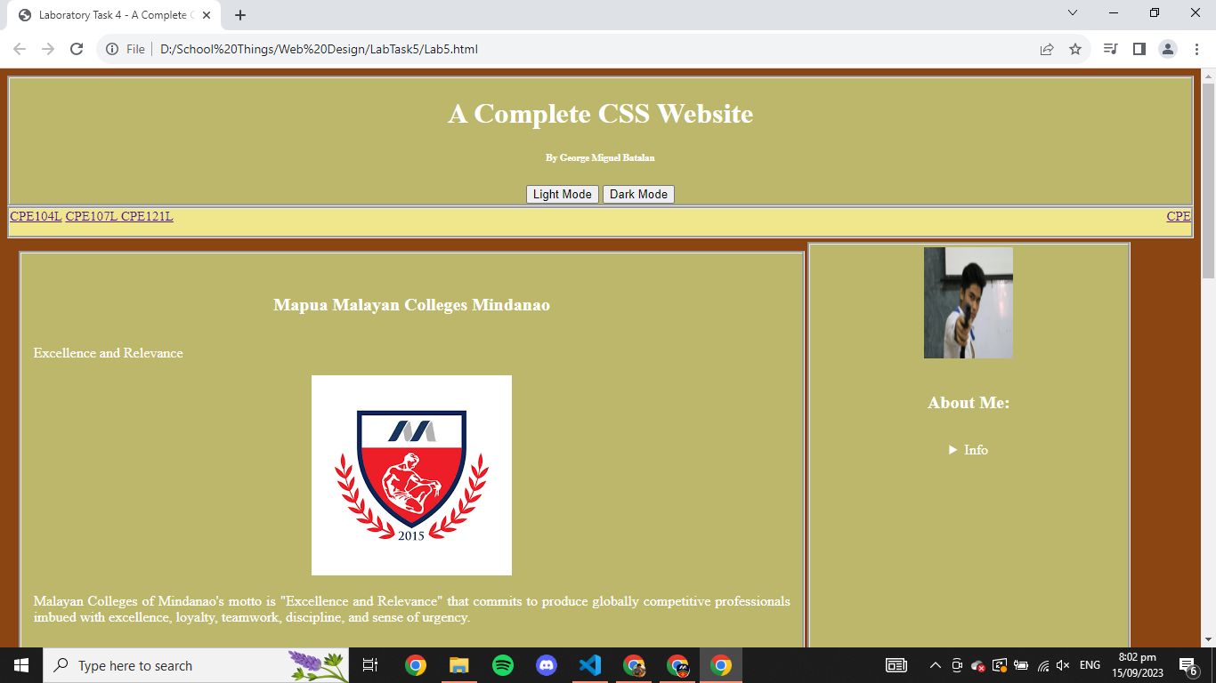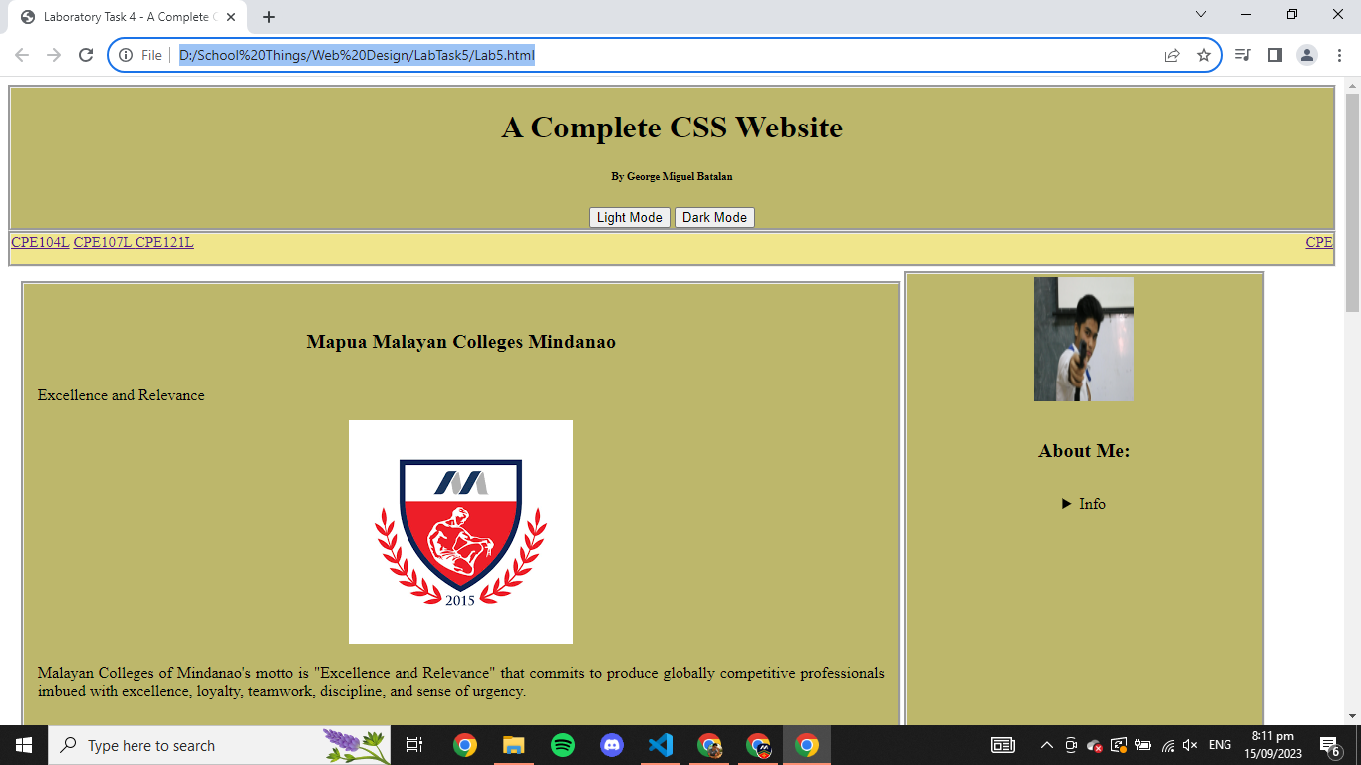

**Findings and Observations:**

I observed that this can be used as a future preference to the html website we are going to make for people who prefer it to de dark or light because of their eye’s sensitiveness